**Topic 4**

Routers

* It is used to connect LANs together to create internetwork
* Difference between LAN and internetwork

|  |  |
| --- | --- |
| LAN | Internetwork |
| * LAN (for local area network) is a small network of devices connected by one or more interconnecting devices (hubs or switches) in a small geographical area. | * An internetwork is a networked collection of LANs connected by routers. An internetwork can span a small geographical area, a campus or the entire world. |
|  |  |

* Difference between Hub, Switch and Router:

|  |  |  |  |
| --- | --- | --- | --- |
|  | Hub | Switch | Router |
| What does it connects? | Connects computers to form LAN | Connects computers to form LAN | Connects LANs to form internetwork |
| Does it create internetwork? | No | No | Yes |
| Bandwidth | Entire bandwidth of the hub is shared by all devices connected to the hub. If hub is 100Mbps, and 10 devices are connected to the hub, then each device gets 100/10 Mbps. | Each port (device) on the switch gets dedicated bandwidth. If switch is 100Mbps, then each port (device) gets dedicated 100Mbps . | -- |
| What information does it work with? | Bits | Frames | Packets |
| What type of addresses does it work with? | None | MAC addresses | IP addresses |
| What does it do? | Repeats bits on incoming port to all other ports | Forward frames, based on the destination MAC address, to the port with the computer owning the MAC address is found | Forwards packets, based on the destination IP address, to the network where the computer owning the IP address is found |
| Does it forward broadcast frames? | Yes | Yes | No |
| Collision/Broadcast domains | Create a single large collision and broadcast domain | Creates multiple collision domains, but a single broadcast domain | Create multiple broadcast domains |

* Wireless APs and Network Bandwidth
  + Works like hub, except without wires
  + Bandwidth of the network is shared by all wireless client devices (bandwidth sharing)
  + Only one wireless client device can successfully transmit data at a time
  + The more wireless devices connected to the wireless LAN, the lesser bandwidth for each wireless client devices
  + Wireless LANs can only operate in half-duplex (wireless client devices can send or receive, but not both, at the same time)
* How Switch (or Hub), Router and AP used in a network?

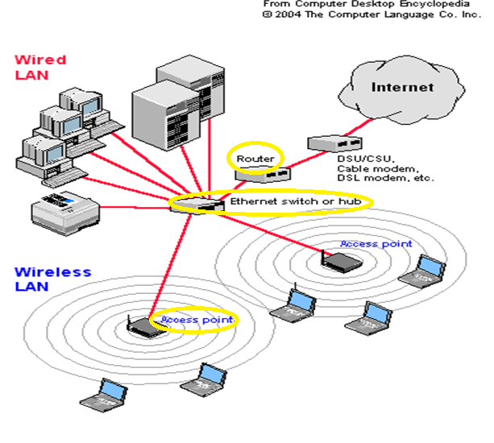

Network Interface Cards (NICs)

* It provides the physical connection from the computer to the network medium
* Network medium could be wired (copper wire, cable or fibre optics) or wireless (radio frequencies)
* NIC can be built into computer’s motherboard or added on as an additional card
* Handles incoming/outgoing frames into/out of a computer

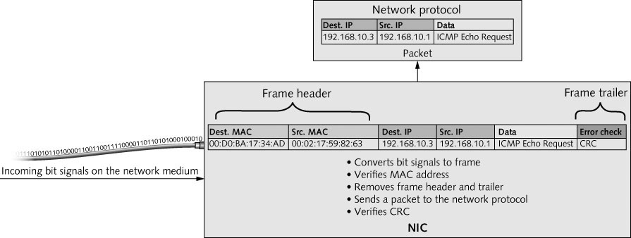

* Incoming data (frame):
  + Receives bit signals and assembles them into frames
  + Verifies the destination MAC address
  + Verifies the CRC
  + Removes frame header/trailer and sends the resulting packet to the network protocol layer

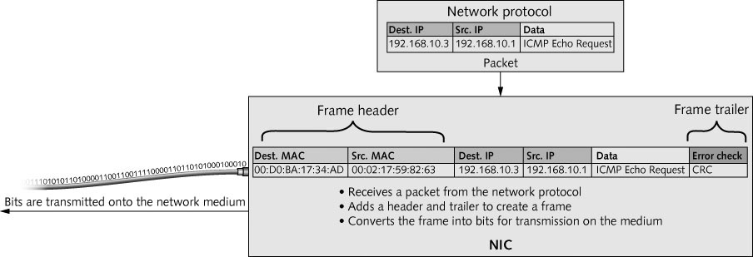

* Outgoing data (frame):
  + Receives packet from the network protocol layer
  + Adds the frame header and trailer (CRC), to form the frame
  + Converts the frame into bits for transmission on the network medium
* Each NIC has a unique MAC address burned-in to the read-only memory (ROM) on the NIC
* MAC address is 48 bits divided into 2 parts:
  + First 24-bit is the manufacturer ID (or OUI Organisation Unit Identifier)
  + Second 24-bit is the card serial number
* MAC address is express in hexadecimal digit
* An example: 00000100 01000000 00110001 01011011 00011010 11111000

04 : 40 : 31 : 5B : 1A : F8

* A special MAC address where all the 48-bits are ‘1s’ is the broadcast address

11111111 11111111 11111111 11111111 11111111 11111111

FF : FF : FF : FF : FF : FF

* Frame with destination MAC address all “1s” is a broadcast frame meant for all computers in the network
* Unicast frame 🡪 destination frame MAC address matches the burned-in MAC address of a NIC (it is only for that computer)
* NIC acts as a Gatekeeper 🡪 it only permits inbound frames if the destination MAC matches:
  + The NIC’s burned-in MAC address; or
  + Is a broadcast frame (FF:FF:FF:FF:FF:FF)
* Promiscuous mode is when gatekeeper function is turn off to allow the NIC to accepts all frames it receives (used when computer is running a protocol analyser like Wireshark)

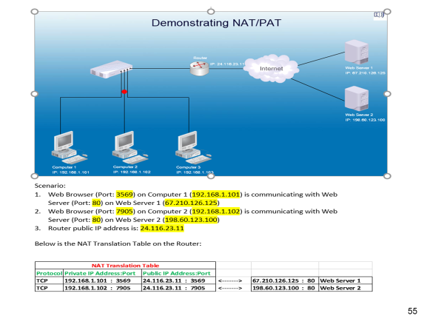

Links to video:

1. Difference between Hub, Switch and Router

<https://www.youtube.com/watch?v=1z0ULvg_pW8&list=RDCMUCJQJ4GjTiq5lmn8czf8oo0Q&start_radio=1&t=1>

1. Difference between Wireless Access Point (WAP) and Wireless (Wifi) Router

<https://www.youtube.com/watch?v=OxiY4yf6GGg>

1. 2.4GHz vs 5.0GHz Wireless LAN

<https://www.youtube.com/watch?v=J_bf_KE5llQ>

1. What is a Firewall?

<https://www.youtube.com/watch?v=kDEX1HXybrU>

1. What is a DMZ?

<https://www.youtube.com/watch?v=dqlzQXo1wqo>

1. How a packet gets routed through a network?

<https://www.youtube.com/watch?v=rYodcvhh7b8>

Practical 5 (ping)

ping



Practical 6

HTTP



HTTPS Secure HTTPS



What is favicon.ico? The website icon that is displayed next to the url.

